1. FIND eno whose salary is greater than 4000

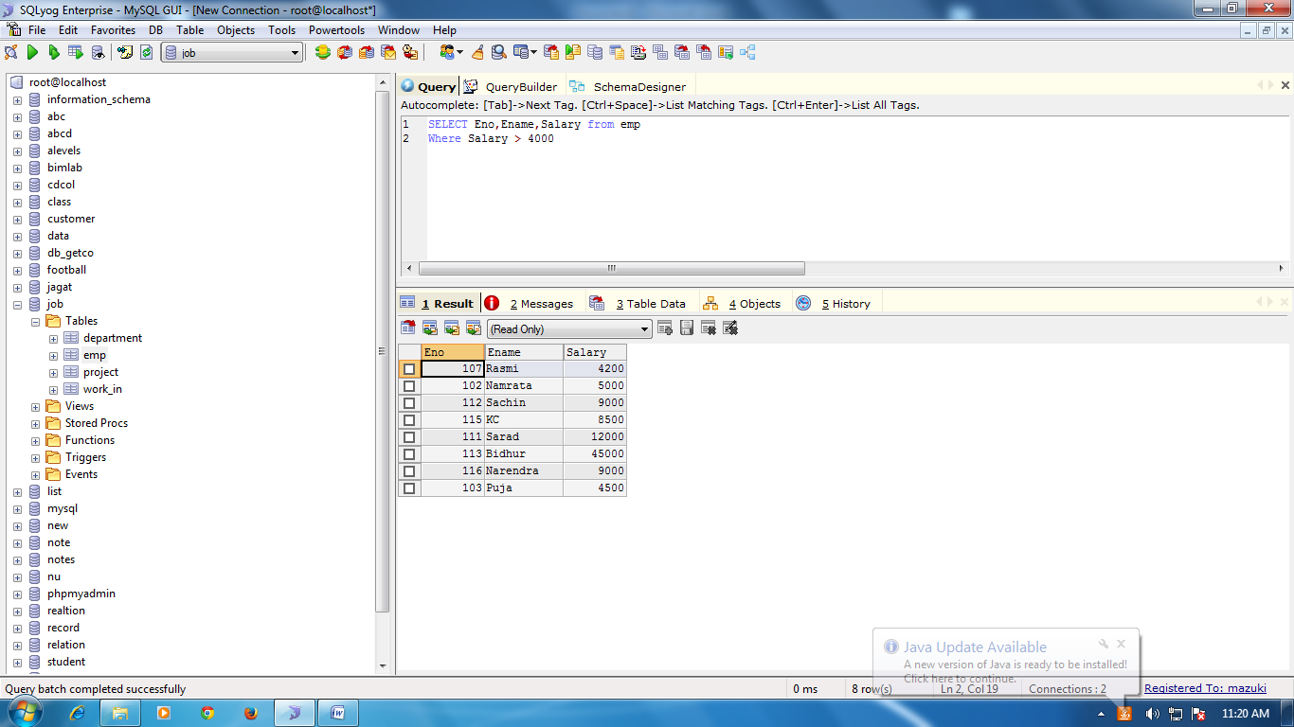

1. Find the eno, ename, salary of the employee whose salary is greater than 5000 and job status is professor.

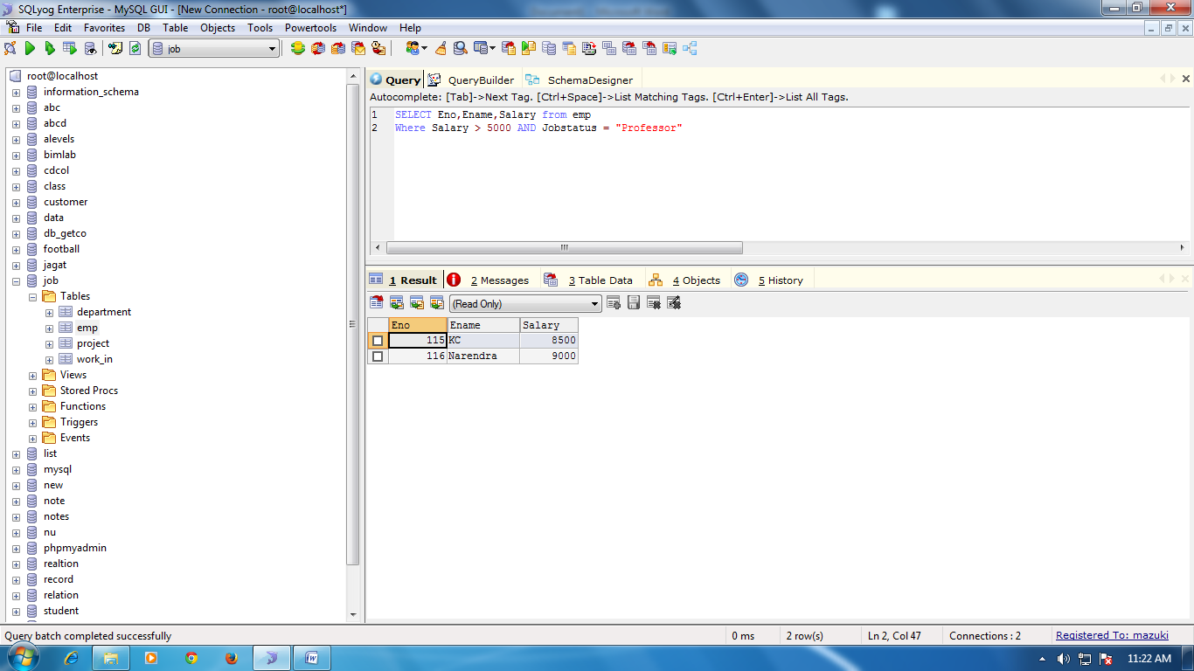



Select address

1. Removing dublicates

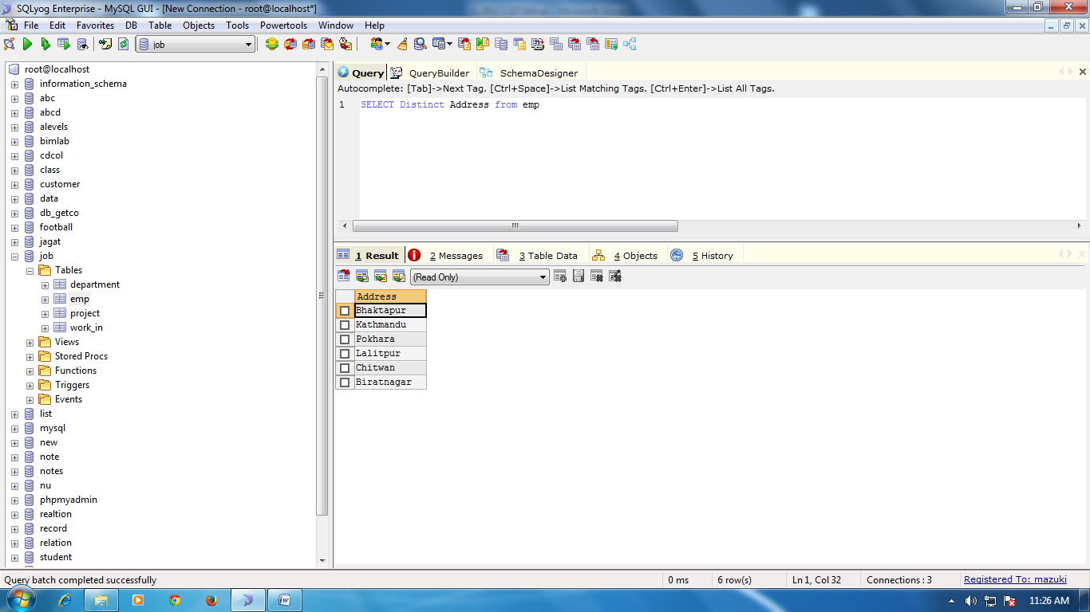

1. Find eno, ename, salary of the employee whose department no. is 20 or job status research fellow

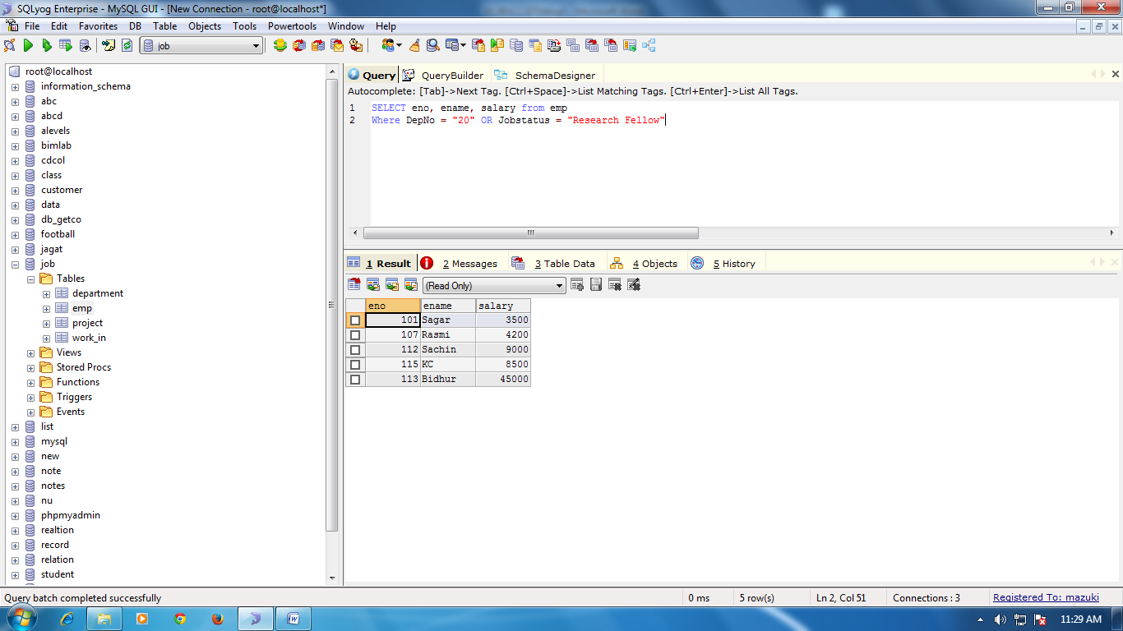

1. Find the eno, ename, age and salary from the employee where age is between 24 and 28.

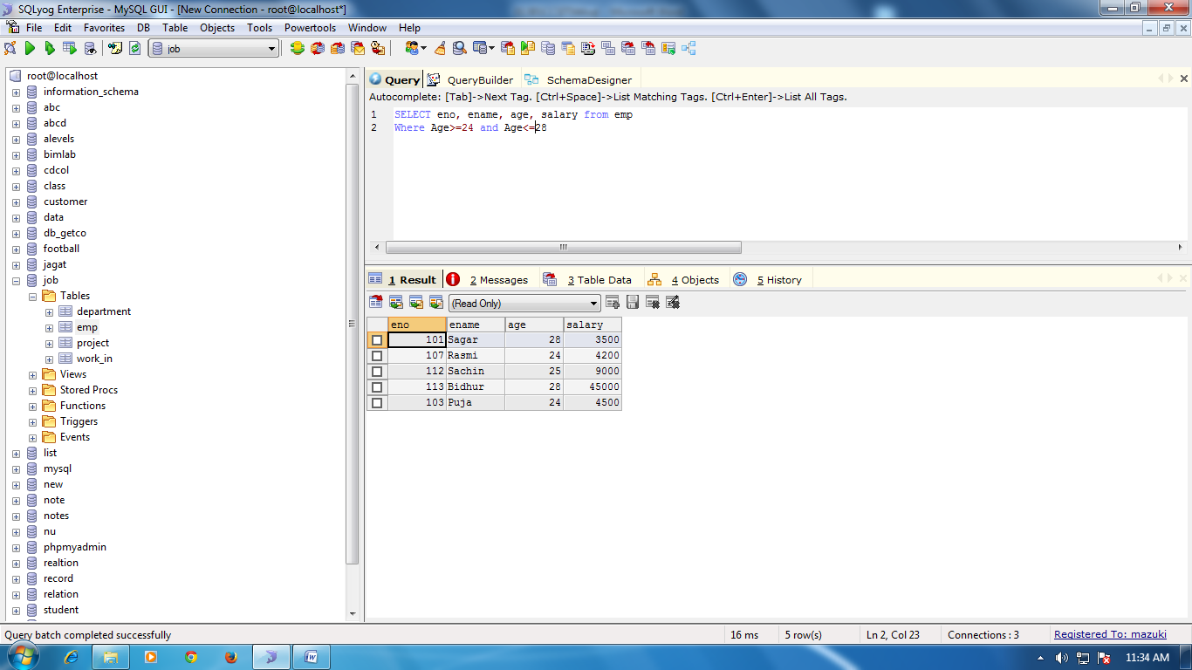

STRING OPERATION

ABC% = A string that starts with ABC.

Eg: ABCDE,ABCBA

%XYZ = All string that end with XYZ.

Eg: WXYZ, ZZXYZ

%AN%= All string that contain AN anywhere.

Eg: LOS ANGELES, SAN FRANCISCO.

1. FIND ENO,ename whose starting letter is Sa

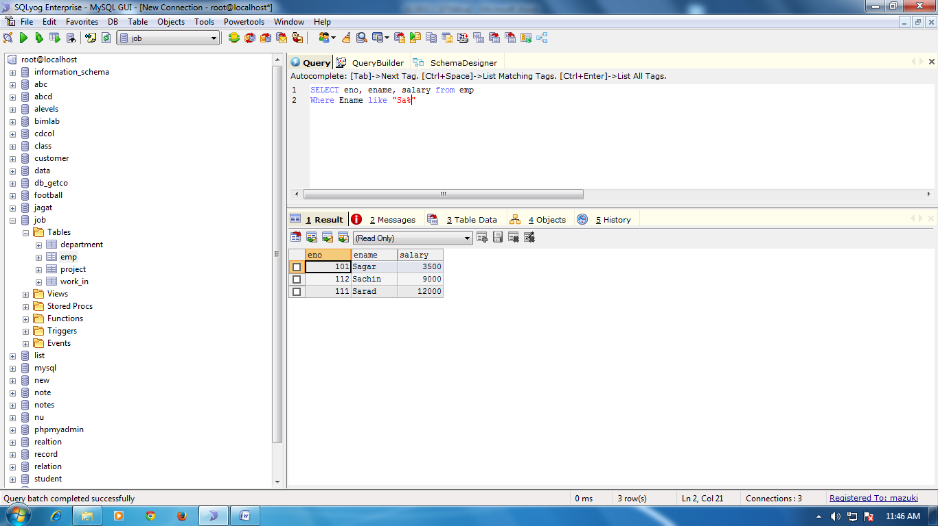

1. List all employee name with their project name

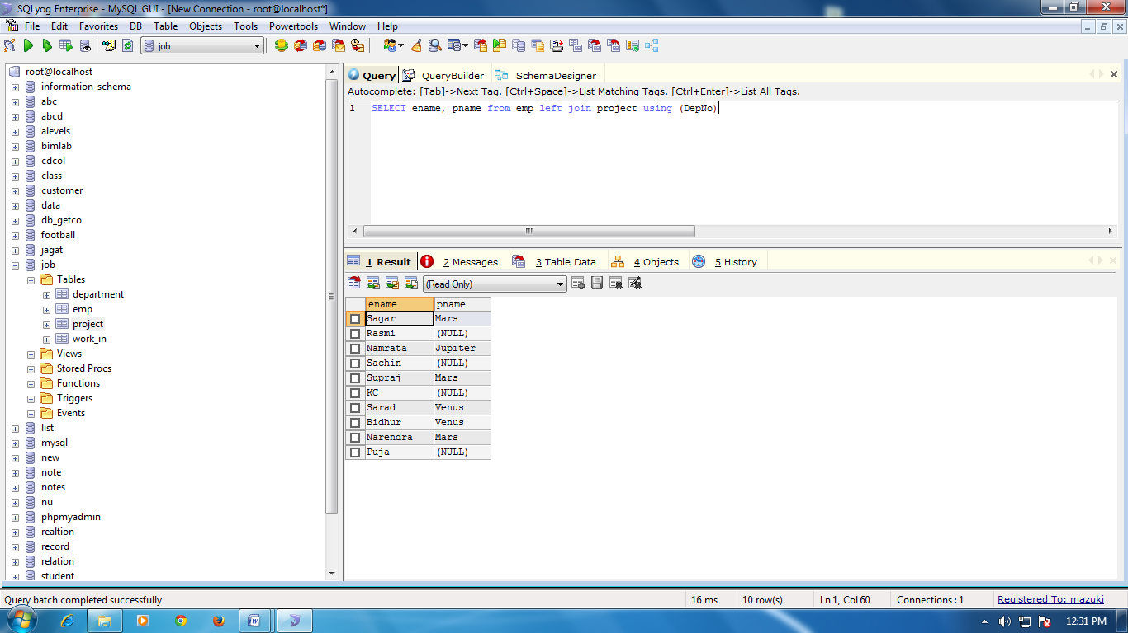

List all employee with their salary working with project earth and venus

List name and salary of employee working in earth and venus

List name and salary of employee working in department which is located in pokhara